Experiment 4

Student Name: Aditi R Sinha UID: 22BCS15130

Branch: BE-CSE **Section/Group: KRG 2B**

Semester:6th Date of Performance: 12/02/2025

Subject Name: Project Based Learning Subject Code: 22CSH-359 in Java with Lab

1. Aim: Write a Program to perform the basic operations like insert, delete, display and search in list. List contains String object items where these operations are to be performed.
2. Objective: The objective of this program is to implement basic operations (insert, delete, display, and search) on a List containing String objects. The program will demonstrate how to manipulate a list using common list operations in Java, providing functionality to manage and interact with data

stored in the list.

1. Implementation/Code:

import java.util.ArrayList;

import java.util.Scanner;

public class StringListOperations {

private static ArrayList<String> list = new ArrayList<>();

public static void insertItem(String item) { list.add(item);

}

public static void deleteItem(String item) {

if (list.contains(item)) { list.remove(item);

System.out.println(item + " has been removed."); } else {

System.out.println(item + " not found in the list.");

}

}

public static void displayList() {

if (list.isEmpty()) {

System.out.println("The list is empty.");

} else {

System.out.println("List items: " + list);

}

}

public static void searchItem(String item) {

if (list.contains(item)) {

System.out.println(item + " is found in the list.");

} else {

System.out.println(item + " is not found in the list.");

}

}

public static void main(String[] args) { Scanner sc = new Scanner(System.in); int choice;

do {

System.out.println("\nSelect an operation:");

System.out.println("1. Insert Item");

System.out.println("2. Delete Item");

System.out.println("3. Display List");

System.out.println("4. Search Item"); System.out.println("5. Exit"); choice = sc.nextInt();

sc.nextLine();

switch (choice) { case 1:

System.out.print("Enter item to insert: "); String insertItem = sc.nextLine(); insertItem(insertItem);

break; case 2:

System.out.print("Enter item to delete: "); String deleteItem = sc.nextLine(); deleteItem(deleteItem);

break; case 3: displayList(); break; case 4:

System.out.print("Enter item to search: "); String searchItem = sc.nextLine(); searchItem(searchItem);

break; case 5:

System.out.println("Exiting program."); break; default:

System.out.println("Invalid choice! Please choose a valid option.");

}

} while (choice != 5);

sc.close();

}

}

1. Output:

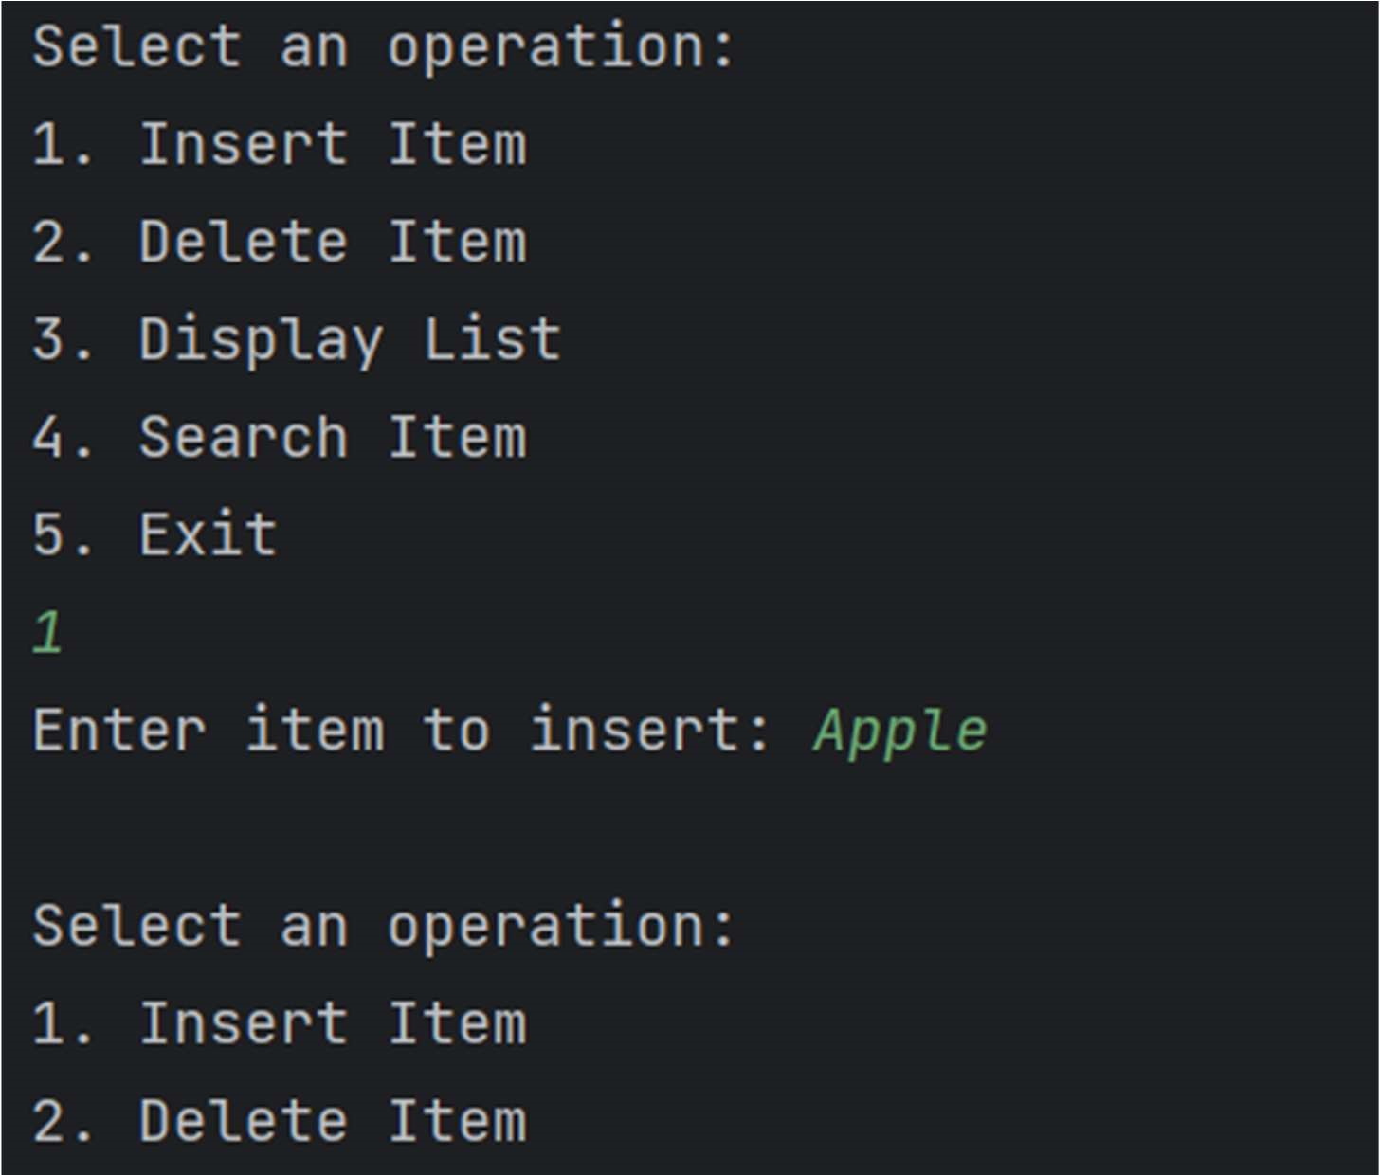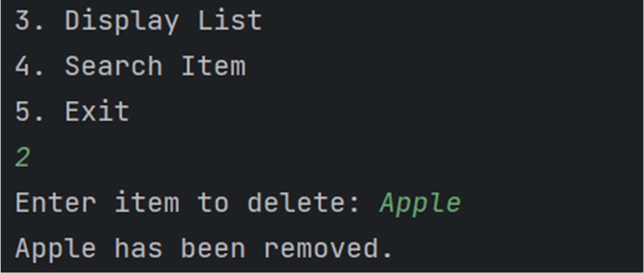

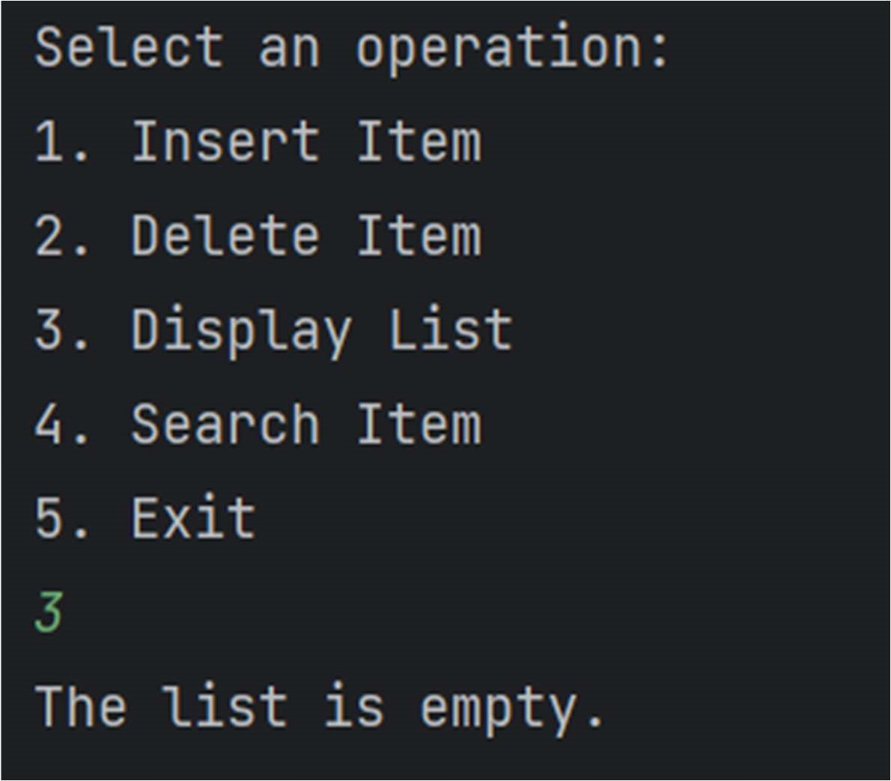

1. Learning Outcomes:
   1. Learn how to perform basic CRUD (Create, Read, Update, Delete) operations on a List of String objects in Java.
   2. Understand how to use the ArrayList class for dynamically storing and manipulating a collection of items.
   3. Practice handling user input using the Scanner class for interaction with the program.
   4. Implement methods for searching, deleting, and displaying items in a list efficiently.
   5. Gain familiarity with control flow and loops to allow for continuous user interaction until the program is exited.